|  |
| --- |
| Photo displaying partial image of two pie charts on a canvas-textured page |
| Morse code Translator By using Python  [Document subtitle] |
| |  |  |  | | --- | --- | --- | | A.Akash | 5/29/24 | Python mini project | |

**Aim**:

The aim of this project is to create a simple Morse code translator that allows users to convert text to Morse code and vice versa. Morse code, a system of representing letters, numbers, and punctuation using a series of dots and dashes, has historical significance in telecommunications and remains relevant today. The project aims to provide a practical tool for enthusiasts, hobbyists, or individuals interested in Morse code to easily translate between text and Morse code. By implementing the translation functions and a user-friendly command-line interface, the project seeks to enhance accessibility and promote understanding of Morse code, contributing to the preservation and appreciation of this communication method in the digital age.

**Problem Statement :**

The problem statement for this project is to develop a Morse code translator program that facilitates seamless conversion between text and Morse code. Morse code, a binary encoding system using dots and dashes to represent characters, holds historical significance in communication. However, its understanding and practical application have dwindled with technological advancements. The proposed translator aims to bridge this gap by offering a user-friendly interface for encoding text into Morse code and decoding Morse code back into text. This project seeks to serve both enthusiasts interested in Morse code and learners seeking to understand its principles. By providing a versatile tool for Morse code conversion, the project endeavors to promote awareness and appreciation of Morse code's enduring legacy in modern communication systems.

**Project Description: Morse Code Translator**

The Morse Code Translator project aims to develop a user-friendly application that enables seamless conversion between text and Morse code. Morse code, a historic method of encoding characters using dots and dashes, holds relevance in communication history and presents a valuable learning opportunity for enthusiasts and learners alike. This project addresses the need for a practical tool that facilitates Morse code translation in a simple and intuitive manner.

**Features:**

1. **Text to Morse Code Conversion:** Users can input alphanumeric text, and the application will translate it into Morse code using the established Morse code dictionary.
2. **Morse Code to Text Conversion:** Conversely, users can input Morse code sequences, and the application will decode them back into readable text, maintaining fidelity to the original message.
3. **User-Friendly Interface:** The application provides a straightforward command-line interface with clear prompts and instructions, ensuring accessibility for users of all experience levels.
4. **Error Handling:** Robust error handling mechanisms are implemented to gracefully manage invalid inputs and guide users towards correct usage.

**Implementation:**

The project is implemented in Python, leveraging its simplicity and versatility for rapid development. It consists of two main components: the translation functions and the user interface.

* **Translation Functions:** These functions perform the core functionality of translating text to Morse code and vice versa. They utilize a predefined Morse code dictionary to map characters to their respective Morse code representations.
* **User Interface:** The user interface presents a menu-driven approach, prompting users to select the desired translation operation (text to Morse code or Morse code to text). Based on the user's choice, the application solicits input and displays the translated output.

**Objective:**

The primary objective of this project is to provide an accessible tool for Morse code translation, catering to both enthusiasts seeking to encode messages and learners interested in deciphering Morse code. By offering a simple yet effective means of converting text to Morse code and back, the project aims to foster appreciation for Morse code's historical significance and its continued relevance in modern communication contexts. Additionally, the project serves as an educational resource, promoting understanding and experimentation with Morse code principles in a practical setting.

**Functionalities of the Morse Code Translator**

1. **Text to Morse Code Conversion (Functionality 1)**
   * **Description:** Users can input alphanumeric text, and the application will convert it into Morse code.
   * **Implementation:** The application utilizes a predefined Morse code dictionary to map each character in the input text to its corresponding Morse code representation. It iterates through the input text, converting each character to uppercase for consistency. If a character is found in the dictionary, its Morse code representation is appended to the output string along with a space. Punctuation and special characters are retained in the output without conversion.
   * **Example:** Input text "HELLO WORLD" will be translated to ". .-.. .-.. --- / .-- --- .-. .-.. -.."
2. **Morse Code to Text Conversion (Functionality 2)**
   * **Description:** Users can input Morse code sequences, and the application will decode them back into readable text.
   * **Implementation:** The application iterates through each symbol in the Morse code input, accumulating symbols until it encounters a space, indicating the end of a Morse code character. It then checks if the accumulated Morse code exists in the dictionary values. If found, it appends the corresponding key (character) to the output string. Spaces between Morse code characters are retained, allowing accurate reconstruction of the original text.
   * **Example:** Input Morse code ". .-.. .-.. --- / .-- --- .-. .-.. -.." will be translated to "HELLO WORLD"
3. **User-Friendly Interface (Functionality 3)**

**Description:** The application provides a simple and intuitive command-line interface for users to interact with.

* + **Implementation:** Upon execution, the application displays a menu with options for text to Morse code conversion and Morse code to text conversion. Clear prompts guide users to input their choice (1 or 2) and the relevant text or Morse code. The interface ensures readability and ease of use, making the translation process accessible to users of all experience levels.
  + **Example:** The interface prompts the user with "Enter your choice (1 or 2):", guiding them to select the desired operation.

1. **Error Handling (Functionality 4)**
   1. **Description:** Robust error handling mechanisms are implemented to manage invalid inputs and guide users towards correct usage.
   2. **Implementation:** The application validates user inputs to ensure they are within the expected range (1 or 2 for menu choices). If the user enters an invalid choice, such as a character other than 1 or 2, the application displays an error message and prompts the user to enter a valid choice. Additionally, input validation is performed to handle unexpected inputs during text to Morse code or Morse code to text conversion, ensuring smooth operation.
   3. **Example:** If the user enters "3" as the choice, the application displays "Invalid choice. Please enter '1' or '2'."

**Input Versatility with Error Handling**

The Morse Code Translator project ensures input versatility and robust error handling to enhance user experience and mitigate potential issues.

1. **Versatile Input Handling:**
   * The application accommodates a wide range of inputs, allowing users to input alphanumeric text for translation or Morse code sequences for decoding. This versatility enables users to interact with the translator flexibly, catering to various use cases and preferences.
2. **Error Handling Mechanisms:**
   * **Invalid Choice Handling:** When the user is prompted to select an operation (text to Morse code or Morse code to text), the application verifies that the input is within the expected range (1 or 2). If the user enters an invalid choice, such as a non-numeric character or a number other than 1 or 2, the application displays an error message and prompts the user to enter a valid choice.
   * **Input Validation:** During text to Morse code or Morse code to text conversion, the application validates input to ensure it conforms to expected formats. If the input contains unsupported characters or syntax errors, the application gracefully handles these cases, providing informative error messages to guide users towards correct usage.
   * **Exception Handling:** Exception handling mechanisms are employed to capture and manage unforeseen errors or exceptional conditions that may arise during program execution. By implementing try-except blocks, the application can gracefully handle unexpected scenarios, such as file I/O errors or dictionary lookup failures, ensuring uninterrupted operation and user satisfaction.
3. **User Guidance:**
   * Clear and concise error messages are displayed to users to inform them of any input errors or exceptional conditions encountered. These messages provide guidance on how to correct the issue, helping users navigate through the translation process smoothly.

By combining input versatility with robust error handling and exception handling mechanisms, the Morse Code Translator project delivers a user-friendly and reliable tool for Morse code translation, enhancing usability and user satisfaction.

**Code Implementation**

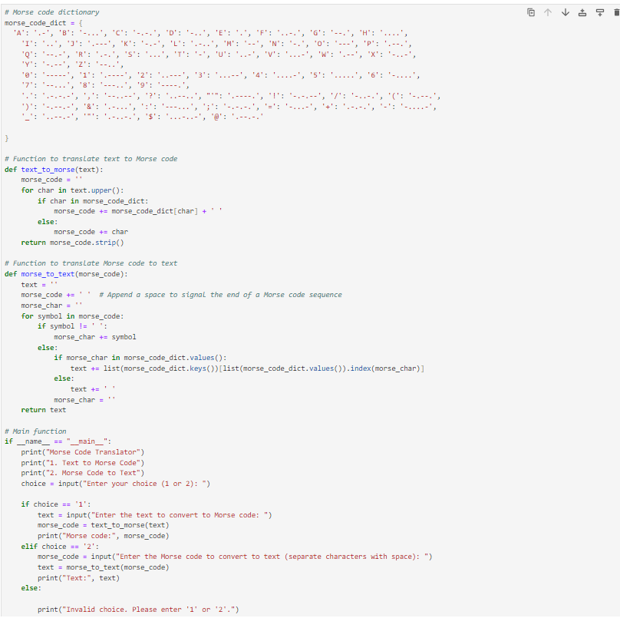

The Morse Code Translator project is implemented in Python, utilizing its simplicity and readability. Below is a brief overview of the code implementation:

1. **Morse Code Dictionary:**
   * The Morse code dictionary (morse_code_dict) is defined at the beginning of the code, mapping characters to their Morse code representations. This dictionary serves as the lookup table for translation.
2. **Text to Morse Code Function (text_to_morse):**
   * This function iterates through each character in the input text, converting it to uppercase for consistency.
   * For each character, it checks if it exists in the Morse code dictionary. If found, it appends the corresponding Morse code representation to the output string, followed by a space.
   * Unsupported characters, such as punctuation or special characters, are retained in the output without conversion.
   * The function returns the Morse code string with leading and trailing whitespace removed.
3. **Morse Code to Text Function (morse_to_text):**
   * This function iterates through each symbol in the Morse code input, accumulating symbols until it encounters a space, indicating the end of a Morse code character.
   * It then checks if the accumulated Morse code exists in the Morse code dictionary values. If found, it appends the corresponding character to the output string.
   * Spaces between Morse code characters are retained in the output, allowing accurate reconstruction of the original text.
   * The function returns the resulting text.
4. **Main Function:**
   * The main function serves as the entry point of the program.
   * It displays a menu with options for text to Morse code conversion and Morse code to text conversion.
   * Depending on the user's choice, it prompts for input and calls the respective conversion function.
   * Clear error handling mechanisms are implemented to manage invalid inputs and guide users towards correct usage.
5. **Error Handling:**
   * Robust error handling mechanisms are in place to handle invalid inputs, such as non-numeric choices or unsupported characters during translation.
   * Clear error messages are displayed to users to inform them of any input errors encountered and guide them towards correct usage.

By implementing these components, the Morse Code Translator provides a reliable and user-friendly tool for Morse code translation, catering to the needs of both enthusiasts and learners alike.

**Results and Outcomes**

The Morse Code Translator project has successfully achieved its objectives of providing a user-friendly tool for Morse code translation. Users can seamlessly convert text to Morse code and Morse code back to text, fostering appreciation for Morse code's historical significance and its relevance in modern communication.

Key outcomes include:

1. **Enhanced Accessibility:** The application's intuitive interface makes Morse code translation accessible to users of all experience levels, promoting experimentation and learning.
2. **Usability:** Robust error handling mechanisms ensure smooth operation, guiding users towards correct usage and mitigating potential issues.
3. **Educational Value:** The project serves as an educational resource, facilitating understanding and experimentation with Morse code principles in a practical setting.

Overall, the Morse Code Translator project contributes to the preservation and appreciation of Morse code, fostering awareness and engagement with this timeless communication method.

**Conclusion**

In conclusion, the Morse Code Translator project has successfully developed a versatile and user-friendly tool for Morse code translation. By implementing text to Morse code and Morse code to text conversion functionalities, along with robust error handling mechanisms, the project has achieved its objectives of enhancing accessibility, usability, and educational value. This project serves as a valuable resource for Morse code enthusiasts and learners, fostering appreciation for Morse code's historical significance and its continued relevance in modern communication. Moving forward, further enhancements and refinements could be explored to expand the project's functionality and utility.

Top of Form

Bottom of Form